Java Interview

# Java Core

## Multithreading, concurrency and thread basics

1. What is Thread in Java?

* Threads consumes CPU in best possible manner, hence enables multi processing. Multi threading reduces idle time of CPU which improves performance of application.
* Thread are light weight process.
* A thread class belongs to java.lang package.
* We can create multiple threads in java, even if we don’t create any Thread, one Thread at least do exist i.e. main thread.
* Multiple threads run parallelly in java.
* Threads have their own stack.
* Advantage of Thread : Suppose one thread needs 10 minutes to get certain task, 10 threads used at a time could complete that task in 1 minute, because threads can run parallely.

1. Does Thread implements their own Stack, if yes how? (Important)

Yes, [Threads have their own stack](http://www.javamadesoeasy.com/2015/03/threads-implement-their-own-stack.html). This is very interesting question, where interviewer tends to check your basic knowledge about how [threads internally maintains their own stacks](http://www.javamadesoeasy.com/2015/03/threads-implement-their-own-stack.html). I’ll be explaining you the concept by diagram.

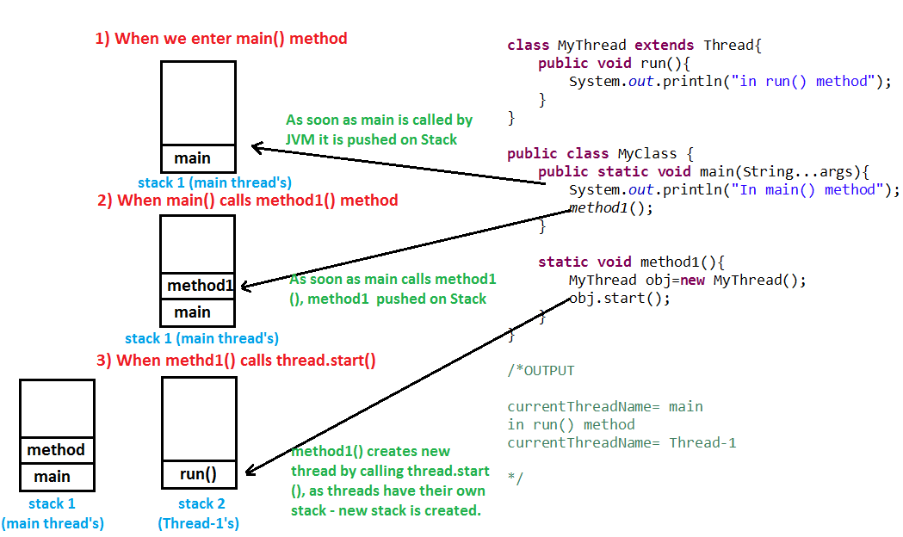

1. What is the difference between a Thread and an Executor?

Creating a running thread in Java is an expensive operation, and an operating system may limit the number of threads provided to a running application at any one time. By using a thread pool, you can create threads when needed, and, rather than creating new threads, you can reuse a thread after it has completed running previous code.

1. How can you ensure all threads that started from main must end in order in which they started and also main should end in last? (Important)

We can use [join() method](http://www.javamadesoeasy.com/2015/03/join-method-ensure-all-threads-that.html) to ensure all threads that started from main must end in order in which they started and also main should end in last.In other words waits for this thread to die. Calling join() method internally calls join(0);

<https://www.journaldev.com/1024/java-thread-join-example>

1. What is significance of using [Volatile](http://www.javamadesoeasy.com/2015/03/volatile-keyword-in-java-difference.html) keyword? (Important)

If a field is declared [volatile](http://www.javamadesoeasy.com/2015/03/volatile-keyword-in-java-difference.html), in that case the Java memory model ensures that all threads see a consistent value for the variable.

<http://www.javamadesoeasy.com/2015/03/volatile-keyword-in-java-difference.html>

1. Why wait(), notify()  and notifyAll() are in Object class and not in Thread class? (Important)

Every Object has a monitor, acquiring that monitors allow thread to hold lock on object.

wait(), notify() and notifyAll() are called on objects only > When wait() method is called on object by thread it waits for another thread on that object to release object monitor by calling [notify() or notifyAll()](http://www.javamadesoeasy.com/2015/03/difference-between-notify-and-notifyall.html) method on that object.

1. What is ThreadLocal?

Java ThreadLocal is used to create thread-local variables. We know that all threads of an Object share it’s variables, so if the variable is not thread safe, we can use synchronization but if we want to avoid synchronization, we can use ThreadLocal variables.  
Every thread has it’s own ThreadLocal variable and they can use it’s get() and set() methods to get the default value or change it’s value local to Thread. ThreadLocal instances are typically private static fields in classes that wish to associate state with a thread. Check this post for small example program showing [ThreadLocal Example](https://www.journaldev.com/1076/java-threadlocal-example).

<https://www.journaldev.com/1076/java-threadlocal-example>

1. Question 20. What is [deadlock](http://www.javamadesoeasy.com/2015/03/deadlock-in-multithreading-program-to.html) in multithreading? Write a program to form [DeadLock](http://www.javamadesoeasy.com/2015/03/deadlock-in-multithreading-program-to.html)in multi threading and also how to solve DeadLock situation. What measures you should take to avoid deadlock? (Important)

https://javarevisited.blogspot.com/2010/10/what-is-deadlock-in-java-how-to-fix-it.html

Two or more threads are waiting for each other to release lock and get stuck for infinite time, situation is called deadlock.



if you provide an ordered access then problem will be resolved , here is my fixed version, which avoids deadlock by avoiding circular wait with no preemption.



1. What are differences between wait and sleep method in Java?

The only major difference is to wait for release the lock or monitor while sleep doesn't release any lock or monitor while waiting. The wait is used for inter-thread communication while sleep is used to introduce pause on execution.

<http://javarevisited.blogspot.sg/2011/12/difference-between-wait-sleep-yield.html>

1. Difference between ExecutorService.submit() and Executor.execute() methods in Java?

<https://javarevisited.blogspot.it/2016/04/difference-between-ExecutorServie-submit-vs-Executor-execute-method-in-Java.html>

1. The real difference between Process and Thread.

The main difference between them  is that a Process is a program which is executing some code and a thread is an [independent path of execution](http://javarevisited.blogspot.com/2014/07/top-50-java-multithreading-interview-questions-answers.html) in the process. A process can have more than one thread for doing independent task e.g. a thread for reading data from disk, a thread for processing that data and another thread for sending that data over the network.

Technically, most significant difference between thread is address space and context switching. All thread from a process share same address space but a process has their own address space. Similarly, context switching between process is more expensive than context switching between threads.

1. Why wait notify and notifyAll called from synchronized block or method in Java

IllegalMonitorStateException in Java which will occur if we don't call wait (), notify () or notifyAll () method from synchronized context.

In order to call the wait (), notify () or notifyAll () methods in Java, we must have obtained the lock for the object on which we're calling the method.

1. How to Stop Thread in Java Code Example

By default, a Thread stops when execution of run() method finish either normally or due to any Exception. In this article, we will How to Stop Thread in Java by using a boolean State variable or flag. Using a flag to stop Thread is a very popular way  of stopping the thread and it's also safe because it doesn't do anything special rather than helping run() method to finish itself.



*Should we make bExit Volatile*

How to Stop Thread in Java Tutorial ExampleSince every Thread has its own local memory in Java

its good practice to make bExit volatile because we may alter the value of bExit

from any thread and make it volatile guarantees that Runner will also see any update done before making bExit.

1. What is the difference between synchronized and concurrent collection in Java?

In Summary concurrent collections use advanced technique to achieve thread-safety without compromising Scalability. For example, [ConcurrentHashMap](http://javarevisited.blogspot.com/2013/02/concurrenthashmap-in-java-example-tutorial-working.html" \t "_blank)only locks certain portion of Map while Hashtable locks full map while doing iteration or performing any write operation.

1. What is the difference between Stack and Heap in Java

Why does someone this question as part of multi-threading and concurrency? because Stack is a memory area which is closely associated with threads. To answer this question, both stack and heap are specific memories in Java application. Each thread has their own stack, which is used to store local variables, method parameters and call stack. Variable stored in one Thread's stack is not visible to other. On another hand, the heap is a common memory area which is shared by all threads. Objects whether local or at any level is created inside heap. To improve performance thread tends to cache values from heap into their stack, which can create problems if that variable is modified by more than one thread, this is where volatile variables come into the picture. volatile suggest threads read the value of variable always from main memory. See this [article](http://javarevisited.blogspot.com/2013/01/difference-between-stack-and-heap-java.html) for learning more about stack and heap in Java to answer this question in greater detai

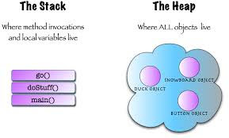

1. How to check if a thread holds lock on a particular object in Java

* I thought about **IllegalMonitorStateException**which [wait() and notify() methods](http://javarevisited.blogspot.com/2011/05/wait-notify-and-notifyall-in-java.html)throw when they get called from non-synchronized context so I said I would call newspaper.wait() and if this call [throws an exception](http://javarevisited.blogspot.com/2012/02/difference-between-throw-and-throws-in.html) it means thread in Java is not holding the lock, otherwise thread holds the lock.
* Later I discovered that thread is a static method called holdsLock(Object obj) which returns true or false based on whether threads holds a lock on the object passed (The java.lang.Thread.holdsLock() method returns true if and only if the current thread holds the monitor lock on the specified object.).

1. JavaRef:

<https://javarevisited.blogspot.it/2011/07/java-multi-threading-interview.html>

<https://javarevisited.blogspot.com/2014/07/top-50-java-multithreading-interview-questions-answers.html>

## Java collections framework